

**Thyroid Regional Assessment and Management Plan**

**TRAMP2**

Thyroid regional assessment and management plan

An electronic version of this document can also be viewed / downloaded

from the North of Tyne and Gateshead Area Prescribing Committee Website at:

<http://www.northoftyneapc.nhs.uk/>

|  |  |
| --- | --- |
| **Endorsed for use within North Tyneside, Northumberland, Newcastle and Gateshead by the North of Tyne and Gateshead APC**  **July 2018** | |
| Review date | Medicines Guidelines and Use Group recommended review date: June 2020 |
| Membership of the guideline consultation group | The development of this guidance was led by Prof. Simon Pearce, Consultant Endocrinologist, NUTH  The Guideline group was multidisciplinary, including representation from all member organisations |

* The purpose of TRAMP2 is to provide guidelines as to testing, interpretation and treatment of common thyroid disorders, for use across primary and secondary care
* TRAMP2 does not consider childhood thyroid disease

**CONTENTS**

Summary page 5

Introduction page 6

Part 1. Screening for thyroid disorders page 7

Part 2. Hypothyroidism page 9

Part 3. Hyperthyroidism page 11

Part 4. Pregnancy page 13

Part 5. Drugs and the thyroid page 14

Part 6. Thyroid nodules and thyroid cancer page 16

Members of guideline development group page 18

Appendix 1 Hypothyroidism algorithm page 19

Appendix 2 Hyperthyroidism algorithm page 20 Appendix 3 Anti-thyroid drug patient information page 21 Appendix 4 Radioiodine patient information page 22 Appendix 5 Levothyroxine replacement in pregnancy page 28 Appendix 6 Additional resources page 29

**Summary**

The purpose of TRAMP2 is to provide guidelines as to testing, interpretation and treatment of common thyroid disorders in adults, for use across primary and secondary care

**SCREENING**

•The laboratory testing strategy is based on an initial serum TSH measurement. If the TSH is abnormal, the lab will cascade additional measurements of free thyroid hormones and thyroid antibodies as appropriate.

**HYPOTHYROIDISM**

•An elevation of serum TSH is the most sensitive indicator of primary hypothyroidism.

•Serum TSH >10 mU/l confirms overt hypothyroidism and should be treated with levothyroxine replacement. Serum TSH 4.5 to 10 mU/l with low free T4: also overt hypothyroidism- treat with thyroxine.

•Serum TSH 4.5 to 10 mU/l, normal free T4: subclinical hypothyroidism- review symptoms. If symptoms are present, a trial of thyroxine may be appropriate. If symptoms are absent; interval screening of TFT is sufficient.

* In those without ischaemic heart disease, or aged less than 60 years, a full replacement dose of levothyroxine (~1.5 mcg/kg) should be started.

• In those with ischaemic heart disease or aged >60, a smaller dose of thyroxine (25 or 50mcg daily) should be started with upward titration.

* For patients with primary thyroid disease taking levothyroxine, the TSH should be checked annually

•For patients with primary hypothyroidism, the aim is to keep the serum TSH within the reference range. For those with persistent hypothyroid symptoms despite treatment, aim for the lower half of the TSH range (TSH 0.3 to 2.0 mU/l).

•Occasional patients taking levothyroxine have different monitoring targets (eg. in pregnancy; following thyroid cancer; pituitary disease).

**HYPERTHYROIDISM**

* A serum TSH < 0.1 mU/l, with either a raised FT4 or FT3 indicates hyperthyroidism

•Patients with hyperthyroidism should be referred to specialist services.

•Once hyperthyroidism is confirmed, therapy includes beta blockers. If symptoms are severe, or unstable cardiovascular state (eg. AF), carbimazole can be initiated in primary care. However, it may be best to discuss with endocrinologist at local hospital prior to initiating carbimazole therapy.

**PREGNANCY**

•Interpretation of thyroid function tests needs modification during pregnancy, to encompass trimester-specific reference ranges and differing clinical priorities.

•Pregnant patients with thyroid disorders should generally be managed in medical obstetric clinics or with close obstetrician-physician liaison.

•People at high risk of thyroid dysfunction are recommended to have thyroid function checked prior to pregnancy or as soon as possible after pregnancy is confirmed.

•Patients treated with thyroxine replacement generally require an increase in the dose of thyroxine by 25µg daily as soon as pregnancy is confirmed.

**AMIODARONE & LITHIUM**

•People taking amiodarone and lithium salts should have thyroid function testing before treatment, and every 6 months thereafter.

**THYROID NODULES**

•The discovery of a (new) discrete thyroid nodule should be referred directly to specialist services. In the presence of lymphadenopathy, rapidly expanding mass or painless loss of voice, the patient should be referred under the 2 week rule

•In the presence of airway obstruction or stridor, referral should be as an emergency.

•Neck ultrasound is not recommended prior to referral.

**Introduction**

Abnormalities of thyroid function are commonly encountered in all areas of medical practice, with more than 2% of people suffering an overt thyroid disorder over a lifetime and an additional 5% of the populations with biochemical abnormalities of subclinical thyroid disorders. Overall, there are about 23 million prescriptions for thyroxine dispensed annually in England, and approximately 120,000 requests for serum thyroid function testing are received by the Newcastle upon Tyne Foundation NHS Trust laboratories annually. Optimal delivery of healthcare for thyroid patients, and those suspected of having thyroid disease, is therefore important, both in terms of the numbers of patients affected and in the substantial resources deployed. The aim of the guideline is to form a rational basis for good practice in thyroid function testing and the management of common thyroid problems in the Newcastle, Northumbria & North and South of Tyne region. The guideline will provide a framework for the local implementation of the detailed National (British Thyroid Association/ Association of Clinical Biochemists) guidelines on thyroid function testing, the Royal College of Physicians/ British Thyroid Association Guidelines on use of radioiodine for benign thyroid disease, updated British Thyroid Association Guidelines for the management of thyroid cancer (2014) and a British Thyroid Association /Society for Endocrinology statement on hypothyroidism.

The scope of the guideline is to encompass all adults over 18 years with thyroid disease or suspected thyroid disease (including pregnancy), but children and young people are not included. The aim is to provide guidance for primary care, and for secondary care provided by non-endocrinologist hospital services, including mental health services.

***Format of the guideline***

The guideline has 2 parts; a summary for use in primary care (at the start of this document) which can be folded to be double sided A5, easily laminated and kept readily available, and a set of supporting resource notes with more detailed recommendations. Clinicians seeing patients with thyroid disorders should be familiar with the main document, but may wish to use the summary as an everyday reminder.

# Part 1. Screening for thyroid disorders

## Background

•The laboratory testing strategy is based on an initial serum TSH measurement. If the TSH is abnormal, the lab will cascade additional measurements of free thyroid hormones and thyroid peroxidase antibodies as appropriate.

•A normal serum TSH excludes primary thyroid disease, but could be consistent with the much rarer problem of central or secondary hypothyroidism due to hypothalamic/pituitary disease. These patients invariably have other hormonal dysfunction (eg. secondary amenorrhoea, hypogonadism, hyperprolactinaemia, hyponatraemia).

•The information returned from the laboratory will be enhanced by recording basic clinical details (eg. ‘suspected hypothyroidism’ or ‘on thyroxine’) on the request card- coded as TF1-TF4 etc. For rarer situations TF5 codes can be used to specify pregnancy, amiodarone etc. Clinicians in Gateshead are able to record reason for requesting thyroid function test on a drop-down box on the ICE requesting system.

•The reference ranges quoted by labs around the region (Newcastle, Gateshead, Northumbria) have been unified, as below.

|  |  |  |  |
| --- | --- | --- | --- |
|  | **TSH** | **FT4** | **FT3** |
| Range | 0.3–4.5 mU/l | 10.0–22.0 pmol/l | 3.1–6.8 pmol/l |

Please note there are age-related changes in reference range and in particular, the upper limit for FT3 decreases with age, so an older person with TSH<0.05mU/l and FT3 >6.0 pmol/l may have true hyperthyroidism.

•The laboratory will convey the following results back to the requesting clinician, during the next working day:

-TSH >20 mU/l

-TSH >10 with low FT4

-FT4 > 30, with TSH<0.05, or raised FT3

## Who to test ?

* Unselected screening of the general population is not warranted
* Test individuals with features of hyperthyroidism and hypothyroidism

-These symptoms are well-known, and it is more often the combination of manifestations rather than any individual feature that raises the clinical suspicion.

* Screen certain groups for hypothyroidism

-Newly diagnosed hypercholesterolaemia, type 2 diabetes or IHD

-Newly diagnosed major mood disturbance, severe mental illness, dementia

-Following radioiodine or thyroidectomy for hyperthyroidism; early testing 4 to 8 weeks post-procedure; then 3 monthly for 1 year; annually thereafter.

* Screen certain groups for hyperthyroidism:

-New onset atrial fibrillation

-Worsening angina pectoris

-During treatment with tyrosine kinase inhibitors (axitinib and others)

-During treatment with checkpoint inhibitors (pembrolizumab and others)

-Following treatment with alemtuzumab (AKA Campath)

* Some groups require annual surveillance for thyroid dysfunction

-Patients with type 1 diabetes (at annual review)

-Down’s and Turner’s syndrome

-Post neck irradiation

-Past history of post-partum thyroiditis; annual check for 5 years, but also prior to new pregnancy and 6 weeks post future deliveries

-Following drug-induced or painful thyroiditis annually for 5 years

|  |  |  |  |
| --- | --- | --- | --- |
| **Summary table: Routine Screening for thyroid dysfunction** | | | |
| ***Condition*** | ***At diagnosis*** | ***Annually*** | ***Duration*** |
| Type 1 diabetes | + | + | Lifelong |
| Down’s & Turner’s syndrome | + | + | Lifelong |
| Post radioiodine therapy | 3 monthly x4 | + | Lifelong |
| Previous neck irradiation | + | + | Lifelong |
| Postpartum thyroiditis | + | + | 5 yrs |
| Painful or drug-induced thyroiditis | + | + | 5 yrs |
| Hypercholesterolaemia | + | - | - |
| Stable Ischaemic heart disease | + | - | - |
| Type 2 diabetes | + | - | - |
| Severe mood disturbance/ psychosis | + | - | - |

•Other situations

-Hospital inpatients: routine screening in the absence of specific indications is not indicated (exceptions dementia, AF etc.).

-Annual screening in those with established vascular disease, or in those with psychiatric disorders, is not recommended.

-Screening in simple obesity is not recommended, but is reasonable prior to

starting a pharmacological intervention. Obesity per se is associated with a small elevation in serum TSH which is reversible on losing weight and doesn’t indicate hypothyroidism (TSH 4.5–10 mU/l), or warrant treatment.

-See section 5 for details about amiodarone, lithium and other drug effects

# Part 2. Hypothyroidism

## Diagnosis

An elevation of serum TSH is the most sensitive indicator of primary hypothyroidism. Free T4 should be measured if TSH is elevated; a low FT4 confirms overt hypothyroidism. Free T3 is normal in most cases of hypothyroidism-it is not a useful investigation. If TFTs do not fit the clinical picture; repeat before considering treatment, which will often be lifelong.

•Serum TSH >10 mU/l confirms overt hypothyroidism and should be treated with levothyroxine replacement

•Serum TSH 4.5 to 10 mU/l, low free T4: also overt hypothyroidism- treat with levothyroxine

•Serum TSH 4.5 to 10 mU/l, normal free T4: subclinical hypothyroidism- review symptoms

-If symptoms suggestive of hypothyroidism are present, discuss with the patient and consider a therapeutic trial of close to full-dose thyroxine (eg.75 or 100 mcg daily)

for 3 or 4 months. If there is a symptomatic response over this time, then continue

treatment. If no symptomatic response then check the TSH has been normalised by thyroxine (i.e. subclinical hypothyroidism was corrected). Consider other causes for

symptoms (psychological as well as physical illness).

-If no symptoms, or lack of a symptomatic response to a trial of thyroxine: then check thyroid antibody (TPO antibody) status. If antibodies are negative then recheck TSH in 3 years; if antibodies are positive, then recheck annually (with risks of progression to overt hypothyroidism of ~2% and ~5% yearly, respectively). **See Appendix 1.**

•In overt hypothyroidism it is not generally necessary to ascertain thyroid antibody status. In subclinical hypothyroidism, thyroid peroxidase antibodies predict the rate of progression and hence follow-up interval (1 vs 3 yearly).

## Treatment of hypothyroidism

•Hypothyroidism should be treated with levothyroxine.

•

In those without ischaemic heart disease, or aged less than 60 years, a full replacement dose of levothyroxine should be started.

•A daily thyroxine dose of 100 µg is a suitable starting dose for most women and 125 µg for most men. However, the daily dose is dependent upon body weight, with 1.5 µg of thyroxine per Kg (rounding dose upwards to nearest 25µg), being a rough and ready approximation. See dosing table (below):

|  |  |
| --- | --- |
| Weight (Kg) | Daily thyroxine dose |
| 50 | 75 µg |
| 60 | 100 µg |
| 75 | 125 µg |
| 90 | 150 µg |
| 110 | 175 µg |

•TSH may take 3 to 6 months to ‘normalise’ in people who have had a prolonged period of hypothyroidism (initial TSH >50 mU/l), even with full levothyroxine replacement. This is owing to pituitary thyrotroph hyperplasia.

•In those with known ischaemic heart disease, or over 60 years old, a starting dose of 50 µg daily is generally appropriate, with repeat TSH after 8 weeks and further dose titration as indicated. As long as the TSH is falling, there may be no need to increase the daily thyroxine dose. If there is no, or minimal, reduction in TSH a cautious upward titration of thyroxine dose is indicated. In those with recent MI, uncontrolled or unstable angina pectoris, or uncontrolled AF, a lower starting dose (12.5 or 25 µg daily) should be used, with monthly increments until TSH is within reference range.

•Failure to normalise TSH following 6 months levothyroxine treatment

-Check patient medication concordance & explain long half-life of thyroxine

-Check for medications interfering with thyroxine absorption:

* + Calcium and Iron salts
  + Proton pump inhibitors/ antacids
  + Cholestyramine/ colesevelam

-Consider malabsorption, eg. celiac disease, pernicious anaemia/ atrophic gastritis

•Patients who are pregnant, or who have unstable cardiac conditions may need specialist management. Also consider endocrine referral for patients with overt hypothyroidism whose symptoms don’t respond to levothyroxine, or who have persistently abnormal TSH.

•There is no high-quality evidence to favour use of T3 (liothyronine) either on its own, or in combination with levothyroxine, or ‘natural’ dessicated animal thyroid extracts for treatment of hypothyroidism.

## Monitoring

For patients with primary thyroid disease taking levothyroxine, the TSH should be checked annually

•For patients with primary hypothyroidism, the aim is to keep the serum TSH within the reference range. For those with persistent hypothyroid symptoms despite treatment, aim for the lower half of the TSH range (TSH 0.3 to 2.0 mU/l).

•For patients with central/secondary hypothyroidism (owing to pituitary/ hypothalamic disease), the TSH is unreliable (often undetectable) and monitoring of thyroid replacement is best judged clinically, and using serum FT3 & FT4 measurement.

•For many patients with treated thyroid cancer, particularly in the first year since treatment, the aim of the levothyroxine treatment is suppression of the serum TSH to <0.1 mU/l.

# Part 3. Hyperthyroidism

## Diagnosis

* A serum TSH < 0.1 mU/l, with either a raised FT4 or FT3 indicates hyperthyroidism.

If tests indicate hyperthyroidism, TSH-receptor autoantibodies (TRAb) should be measured (confirming the diagnosis of Graves’ disease in most). The laboratories in Newcastle and Gateshead will trigger the request automatically as assay is provided by biochemistry. In Northumbria HCT a separate request to immunology is needed. Thyrotoxicosis with raised FT3 but normal FT4 is termed T3 thyrotoxicosis: treatment is the same as for regular hyperthyroidism. **See Appendix 2**

* If the serum TSH is <0.1 mU/l with normal FT4 and/or FT3, repeat the TFT in 4 to 6 weeks, or earlier if strong suspicion of hyperthyroidism, or complications thereof (eg. AF).
* A persistent low or suppressed serum TSH (>3 months), with normal serum free thyroid hormones may be due to:

-Chronic non-thyroidal illness *(TSH low)*

-Drug effects, including: *(TSH low or suppressed)*

-prednisolone/ dexamethasone in anti-inflammatory doses

-levodopa, amiodarone, moderate opiate use (eg. tramadol)

-radiographic CT contrast (up to 6 months)

-[levothyroxine treatment]

-Endogenous subclinical hyperthyroidism *(TSH suppressed)*

If clinical suspicion of endogenous subclinical hyperthyroidism, patients may be discussed with, or referred to, an endocrinologist for further assessment (eg. thyroid scan). Action will be determined by the clinical picture and complications (eg. AF, osteoporosis). Progression of subclinical hyperthyroidism to overt hyperthyroidism is infrequent (~5%/year). If low TSH is thought to be due to chronic non-thyroidal illness, further monitoring is not warranted.

## Management

•Patients with hyperthyroidism should be referred to specialist services.

•Most patients with significant thyrotoxicosis can be seen within 14 days at the RVI Rapid Access Endocrinology Clinic: fax clinical details, TFT and a patient contact number to 0191-2820129. Similarly, for Gateshead, most patients can be seen within 14 days in Out-Patient Endocrine Clinics and referral should be faxed to 0191-4456186

•If symptoms are equivocal, repeat blood tests to confirm persistent thyrotoxicosis, ideally after 1 to 2 weeks; if there is a marked reduction in level of FT4 on repeat tests, the diagnosis could be a transient thyroiditis.

•Once hyperthyroidism is confirmed, therapy includes beta blockers such as propanolol LA 80mg daily initially, increasing to bd if needed (eg. re-appearance of palpitations at night). If already treated with a beta blocker, existing treatment could continue, or switch to propanolol. In those with asthma, diltiazem (MR 180mg) is an alternative to beta blockers.

•If symptoms are severe, or unstable cardiovascular state (eg. AF), carbimazole can be initiated in primary care (either 20mg od, or 40mg daily in divided doses). This could be discussed with the on call endocrinologist first, if preferred. For Newcastle Hospitals NHS Trust, a consultant endocrinologist carries a pager (via switchboard). For Northumbria and Gateshead Trusts, please contact the consultant’s secretary via the hospital switchboard. Patients starting carbimazole need to be warned about the possibility of agranulocytosis. A patient information leaflet about antithyroid drugs should be given: see **Appendix 3.**

•Thyroid function tests should be repeated 4 to 6 weeks after starting carbimazole.

•In patients having a trial of medical therapy for Graves’ disease, once the patient is euthyroid (generally after 4 to 8 weeks), levothyroxine can be added in, in a full replacement dose (see section 2); block and replace regimen. Alternatively, the dose of antithyroid drug can be titrated downwards.

•Routine monitoring of full blood count is not required during treatment with carbimazole or propylthiouracil.

•Patients with unstable cardiac symptoms and signs and hyperthyroidism should be discussed immediately with an endocrinologist and/or cardiologist.

•Most patients with hyperthyroidism are managed initially with anti-thyroid drugs and/or primary radioactive iodine (RAI). Thyroidectomy is a less likely initial therapy.

•Radioiodine is a very efficacious, safe and cost effective therapeutic option for hyperthyroidism. For patients with moderate to severe hyperthyroidism (FT4 > 40 pmol/l or FT3 >15 pmol/l at presentation; large goitre) primary radioiodine is a good option, as these individuals rarely enter prolonged remission following anti-thyroid drugs. If severe thyrotoxicosis is present, or thyrotoxicosis with cardiac compromise/ AF, or in the elderly, then radioiodine is the preferred treatment. It is helpful if patients can have a chance to digest the information sheet about RAI, prior to attending clinic (**Appendix 4**).

# Part 4. Pregnancy

## Pre-pregnancy, early pregnancy

•Interpretation of thyroid function tests needs modification during pregnancy, to encompass trimester-specific reference ranges and differing clinical priorities.

•High risk people (as Part 1, plus - personal history of thyroid disease and family history of thyroid disease) are recommended to have thyroid function checked prior to pregnancy or as soon as possible after pregnancy is confirmed.

•Routine screening for thyroid dysfunction is not currently recommended in early pregnancy.

•Pregnant patients with thyroid disorders should generally be managed in medical obstetric clinics or with close obstetrician-physician liaison.

## Previous Hypothyroidism

•Hypothyroid patients planning pregnancy should have their serum TSH optimised to the lower half of the reference range (TSH 0.3 to 3.0 mU/l).

* Serum TSH should be measured at the same time as pregnancy is confirmed, and again after 4 weeks. Patients treated with levothyroxine replacement predictably require an increase in the dose of thyroxine, generally by 25µg daily as soon as pregnancy is confirmed. Women vary though, and those with previous thyroidectomy or radioiodine treatment will have no residual thyroid capacity and will require an increase; whereas those with Hashimoto’s thyroiditis may have some residual thyroid function.

•The consensus first trimester treatment target is a TSH < 2.5 mU/l (NB. Suppressed TSH may be normal in first trimester).

•If initial TSH > 2.5, increase thyroxine dose by 50µg rather than 25µg

•If initial TSH < 0.1, FT4 should be measured. If FT4 elevated, the thyroxine dose should be reduced to the pre-pregnancy dose.

•Under-replacement is likely to be more harmful to fetal and maternal outcomes than

mild over-replacement. The pregnancy-specific references ranges mean that a TSH >2.5 in the first trimester or > 3.0 in the rest of pregnancy should be the threshold to increase levothyroxine dose. See **Appendix 5**

•Post pregnancy, the levothyroxine dose should be returned to pre-pregnancy levels. In many circumstances, it may be practical to simply repeat the TSH at the 6 week post- partum check.

## Previous Hyperthyroidism

•In mothers who have been treated for Graves’ disease, there is a risk of fetal/ neonatal hyperthyroidism, even if the mother is now taking levothyroxine replacement following ablative/surgical treatment (due to persistence of thyroid stimulating antibodies). Such cases should be managed in a joint obstetric/endocrine clinic. TRAb antibodies should be measured in the first trimester, and if present at significant titres, should be rechecked in the second trimester. If high TRAb persist, additional fetal monitoring (scan, heart rate) is required. If TRAb are negative, the risk of fetal hyperthyroidism is very low. Pregnant women previously treated for hyperthyroidism are infrequent.

# Part 5. Drugs and the thyroid

## Amiodarone

About 20% of people taking amiodarone ultimately develop either hypothyroidism or hyperthyroidism. These conditions often adversely affect their cardiac outcome.

*Baseline (pre-Amiodarone)*

•All patients should have thyroid function checked including TSH, FT3 and FT4 along with thyroid antibodies (ATPO).

•Patients with goitre or evidence of hyperthyroidism should be referred for assessment before amiodarone initiated, if possible. In some cases pre-emptive radioiodine ablation may be considered.

*Follow up*

•In persons with normal thyroid (no goitre, normal baseline TFT) the TFT (including TSH, FT3 and FT4) should be checked every 6 months (as recommended by SmPC for

Amiodarone ).

•In persons with a known thyroid problem (goitre, abnormal baseline TFT) tests should be performed more frequently (First at 3 months followed by 4 monthly).

•During the initiation of Amiodarone, there are frequently transiently abnormal thyroid tests. A TFT is not recommended before 3 months after initiation, unless symptoms develop.

•Amiodarone has a long plasma half life of up to 100 days. Thyrotoxicosis has been found up to 9 months to 1 year after amiodarone has been stopped. So thyroid follow up should continue 6 monthly for 1 year after stopping the drug.

•Indications for earlier thyroid testing on amiodarone

Weight loss, unexplained worsening or recurrence of well-controlled arrhythmia, new onset tremor, SoB, tachycardia

*Interpretation of TFT on amiodarone*

•Primarily be guided by TSH level, except in first 3 months of therapy

•FT4 can often be elevated in a euthyroid individual. It is common to see a FT4 of up to 30 pmol/l with normal TSH, indicating euthyroid status.

•High TSH, but normal FT4 often indicates overt hypothyroidism, and warrants cautious

treatment (start with 25µg thyroxine).

•Low FT3 is of no consequence, but high FT3 indicates overt thyrotoxicosis.

## Lithium salts

* Around 50% of people on long-term lithium develop goitre and up to 30% develop hypothyroidism.
* Before initiating Lithium treatment, patients should have careful thyroid clinical examination and blood tests for FT4, FT3, TSH and ATPO
* Thyroid function tests to be monitored 6 monthly. Shared care guideline already available and to be referred to.

## List of drugs potentially causing abnormal thyroid function tests

* Drugs causing abnormal Thyroid function tests without dysfunction

Quetiapine, Phenytoin, Carbamazepine, Androgens, Oestrogens, Tamoxifen, Raloxifene, Nicotinic acid, Rifampicin, Corticosteroids, Methadone, Tramadol Salicylates, Frusemide, Propranolol, Heparin

* Drugs causing Hyperthyroidism

Amiodarone, Iodine contrast agents, Interferon–Alpha, Interleukin-2, Lithium, pembrolizumab, nivolumab, alemtuzumab

* Drugs causing Hypothyroidism

Lithium, Thionamides, Amiodarone, Potassium Iodine solutions, Iodine containing CT contrast agents, Aminoglutethamide

Interferon-Alpha, Interleukin-2, Sunitinib, Sorafenib, Axitinib, ipilimumab, pembrolizumab, nivolumab (thyroiditis)

Bexarotene (central hypothyroidism)

* Drugs interfering with levothyroxine absorption

Calcium Carbonate, Ferrous salts, PPIs, Sucralfate, Cholestyramine, Colestipol, colsevelam

Part 6. Thyroid nodules and thyroid cancer

Thyroid nodules

Patients with a newly discovered thyroid nodule or one which has increased in size over several months should have a serum TSH measurement, and most can be referred routinely.

If any of the following features of concern (Red Flags) are present the patient should be referred under the 2 week rule:

•Rapid painless nodule growth

•Unexplained change in voice

•Palpable cervical lymph nodes

•Thyroid nodule in a child or teenager

*In the presence of airway obstruction or stridor, referral should be as an emergency*

If the patient is hyperthyroid (suppressed TSH), the TSH, FT4 & FT3 should be repeated and referred according to Part 3 (Hyperthyroidism).

Patients with a history of sudden onset of painful thyroid nodule are likely to have bled into a thyroid cyst and can be referred routinely.

Referral to secondary care may NOT be necessary if there is a clear history of a long-standing nodule or goitre that has not changed for several years and there are no other suspicious features (no history of neck irradiation, adult patient, no FH of thyroid cancer, no palpable cervical lymphadenopathy, no stridor).

Referral to secondary care is not recommended for incidentally discovered thyroid nodules on CT, MRI or US unless there are suspicious features in the report, with the exception of incidentally detected thyroid nodules showing positivity of a PET CT scan.

•The primary investigation of a new thyroid nodule in secondary care is an ultrasound of the neck by an experienced operator.

• Neck ultrasound is not recommended prior to referral, as it does not change initial management and delays secondary care assessment.

•Ultrasound is used to triage individuals to different care pathways: those who simply need observation (benign appearances; U2) or those who need evaluation by aspiration cytology (U3–U5), or diagnostic surgery (U3–U5).

•In the presence of an established multinodular goitre, the same Red Flag features of concern (rapid growth, voice change, nodes) should initiate referral (with measurement of TSH). Adolescents and older men are relatively more likely to have cancer.

**Management of thyroid replacement after thyroid cancer.**

•All patients with thyroid cancer are under annual follow up in secondary care, unless the risk of recurrence is deemed to be very remote by the thyroid cancer MDT.

•TSH stimulates thyroid cell growth and needs to be adequately suppressed by levothyroxine therapy.

•Target TSH for most people in the first year following thyroid cancer is < 0.1 mU/l.

To suppress TSH, a daily dose of 175µg or 200µg (occasionally 225µg) levothyroxine is often required. An elevated FT3 > 6.5 pmol/l should be avoided, if possible.

•Individualised TSH targets may be set by the thyroid cancer MDT depending on risk assessment, and these should be communicated to the GP.

•Patients who are discharged by the thyroid cancer clinic, should have a clear a TSH target, recommendations about frequency of thyroid function monitoring, and criteria for referral back to secondary care, which should be communicated to the GP.

•Individuals with medullary thyroid cancer do not require TSH suppression.

•If TFTs are measured in addition to the annual thyroid cancer clinic review, the dose of levothyroxine should not be reduced without being sure this is appropriate.

•If there is any doubt about levothyroxine dose, specialist advice should be obtained. First contact: the thyroid cancer clinical nurse specialist (Nicola Armstrong)- NUTH DECT phone 48654.

# APPENDIX 1

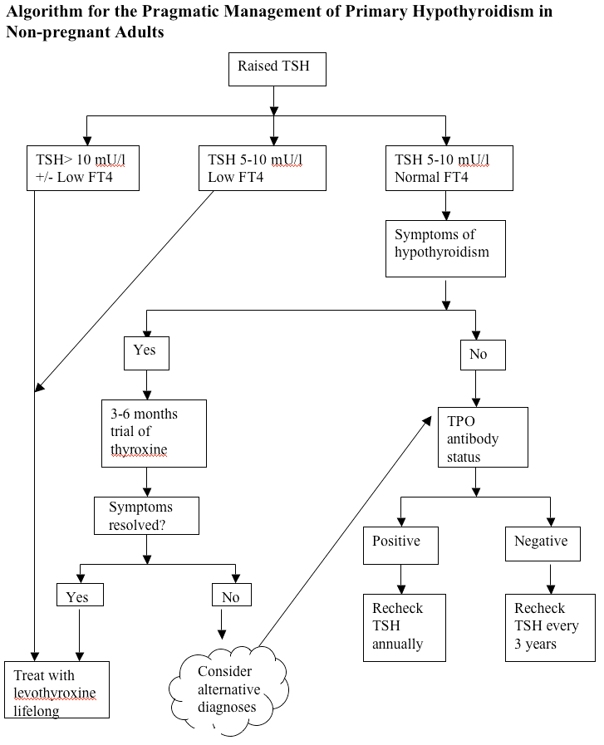

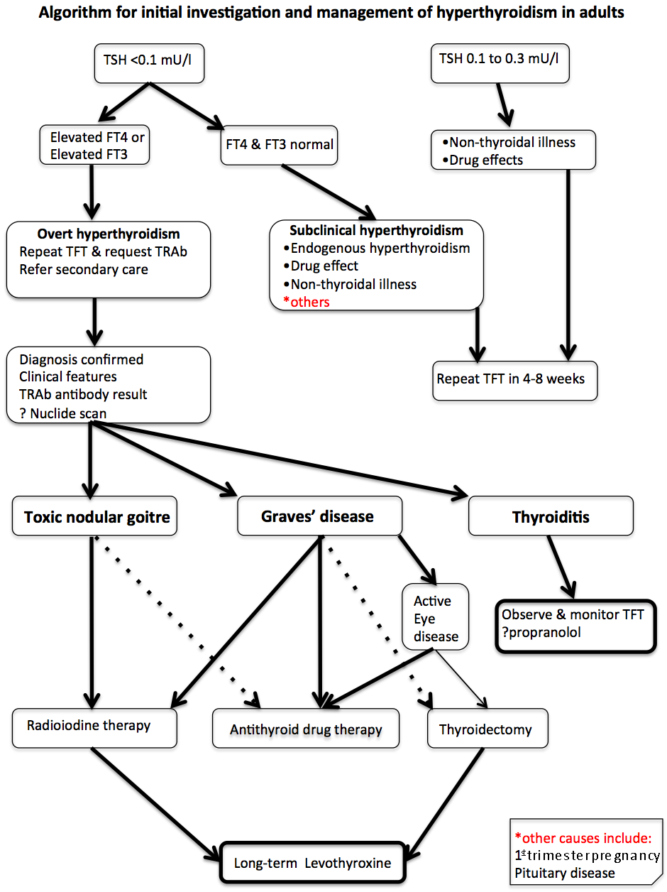

**APPENDIX 3**

**Information for people taking carbimazole or propylthiouracil (PTU) medication**

**Anti-thyroid drugs**

You have been started on treatment with carbimazole or propylthiouracil (anti-thyroid drugs). These drugs control the activity of your thyroid gland. They have been in use for more than 50 years and are safe.

**Potential side-effects**

There are 3 possible side effects that you need to be aware of:

•About 1 in 20 people experience an itchy rash. This is annoying but normally goes away after 1 week, even if you continue the medication.

More rarely, in about 1 in 500 people, the drugs can cause the white blood cells to disappear from your blood. This is a serious problem and you would feel unwell because of infection, with a high temperature (fever) or sore throat. Other less common symptoms are chills/shivering, diarrhoea, aches and pains, cough, mouth ulcers, rash, abdominal pain, vomiting , and headache.

•If you are taking propylthiouracil (PTU), there is a very faint possibility of liver damage occurring, in about one in 10,000 people. You would feel unwell, with nausea, loss of appetite and become jaundiced (white of the eyes goes yellow).

**What to do if you get side-effects**

***Itchy rash***

You may wish to get anti-histamine tablets from the chemist or your doctor to help the itch.

***Sore throat, fever, or other symptoms of infection***

This could be due to a low blood count and must be taken seriously every time it happens. This is what you must do:

•**Do not** take any more medication until you know that it is safe to do so. Stopping the medication for 1-2 days is not dangerous.

•If you have a thermometer, check your temperature. If it is less than 37.5oC (99.5 Fahrenheit), seek immediate medical advice from your GP or out of hours service.

•If your temperature is 37.5oC (99.5 Fahrenheit) or greater, **you must obtain a blood test (“full blood count”) to measure the white blood cells on the same day.** Contact your own doctor (GP), the Programmed Investigation Unit at the RVI (Tel. 0191-2820475), the Newcastle Endocrine Specialist Nurse team if you are a Newcastle patient (0191-2829762 or 0191-2820117), your endocrinologist’s secretary if you are a Northumbria or Gateshead patient or your local Accident and Emergency dept. to get the blood test. If you are unable to contact a doctor, don’t give up, keep trying until you do. If a health professional questions the need for a blood test, insist that it must be done and show this leaflet. Insist that the result of the blood test must be communicated to you on the same day

**Jaundice if you are taking PTU**

If this happens, **stop** the propylthiouracil immediately and contact your doctor, the Programmed Investigation Unit at the RVI (Tel.0191-2820475) or your consultant’s secretary.

# APPENDIX 4

**Information for patients having radioiodine for hyperthyroidism**

This leaflet is intended to support your decision to have radioactive iodine treatment for an overactive thyroid gland. We hope that it will be a useful reminder of the discussion that you had with a member of our team before you consented to have this treatment. If you have not yet decided to have the treatment you may also find it useful.

**Introduction**

Radioactive iodine is a safe treatment which is often used to treat an over active thyroid gland. The thyroid gland concentrates iodine from the blood stream, which makes it possible to deliver radiation specifically to that organ, while sparing the rest of the body. Radioactive iodine stops the excess production of thyroid hormones.

**Intended Benefits of radioactive Iodine**

**• Relief of symptoms of thyrotoxicosis**

**• Avoidance of long-term health problems of thyrotoxicosis**

**Serious or frequently occurring risks of radioactive iodine**

**Radioactive iodine treatment is very safe. There are 2 potential problems.**

* **The development of an under-active thyroid gland (hypothyroidism) that goes undetected**
* **Failure to respond to treatment with radioactive iodine**

Regular monitoring after treatment minimizes the risks of developing hypothyroidism that goes undetected. Failure to respond to radioactive iodine is unusual, but can occur. If you do not respond, we may suggest a period of treatment with drugs to reduce thyroid hormone production, repeat administration of radioactive iodine or consideration of other treatments.

**Benefits and risks of alternative treatments**

* **No treatment: This is likely to result in you feeling less well. No treatment will also place you at risk of the medium to long-term complications with your general health, your heart and your bones.**
* **Alternative treatments for an overactive thyroid gland include anti-thyroid drugs and surgery to remove the thyroid. Anti-thyroid drugs can control thyroid overactivity, but the problem may recur after stopping treatment. The anti-thyroid drugs can also have side effects in some people. Surgery requires control of then thyroid overactivity with medication followed by an operation to remove the gland. This results in permanent hypothyroidism.**

**What radioactive iodine treatment involves**

*Before radioactive iodine treatment*

If you are female we ask for some specific precautions.

* You must not be breastfeeding
* If appropriate you must take contraceptive precautions. You may be asked before your treatment if there is any chance of your being pregnant, and if there is the treatment will be deferred

If you are taking medication to control your thyroid overactivity you will be asked to stop this prior to your treatment and you may be asked to start taking them after the treatment. Your Consultant will give you the details about this.

You should have a low iodine diet for 4 days before the treatment (minimise seafood and dairy products, do not take iodine supplements)

The *Nuclear Medicine* Department will send you an appointment for the treatment. You will need to avoid eating *or drinking for 2 hours before the appointment*. The restrictions you will need to follow will be explained and you will then be asked to swallow a small capsule, which contains a small amount of radioactive iodine. Most of the radioactive iodine goes to your thyroid over the next day, but some will come out in your urine. The radioactivity will not affect the rest of your body and your thyroid will slowly become less active over the next few weeks or months.

*After radioactive iodine treatment*

For the next hour you will be asked not to eat or drink

For the next 4 days you will be asked to do the following:

* Drink plenty of fluids and go to the toilet frequently
* Flush the toilet afterwards and wash hands
* Maintain a low iodine diet

**For people you see regularly (family, friends etc)**

For the next 11 days:

• Stay at least an arms length away from adults and older children (over 5 years) that you see regularly like friends, family and people you work with.

For the next 21 days:

* Stay at least an arms length away from young children (under 5 years) and pregnant women that you see regularly like friends, family and people you work with.

It is fine to spend a few minutes a day within arms length, but avoid any longer periods of time to minimise exposure to others.

For people you see rarely (people in shops, on public transport, etc)

* No restrictions

**Other restrictions**

* Do not donate blood for 6 months after radioactive iodine treatment
* If your are a woman, ensure that you do not become pregnant within **6** months of radioactive iodine treatment
* If you are a man, ensure that you do not contribute to a pregnancy within **4** months of radioactive iodine
* **Nursing mothers: you should cease breastfeeding before the treatment and not restart**

Frequently asked questions

What about my tablets?

**If you have been given tablets to control the thyroid overactivity, you will need to stop taking them before the radioactive iodine treatment. Your doctor will tell you when to stop taking your tablets. You may need to start the tablets again after the treatment and your doctor will advise you if that is the case.**

**Also, if you are taking any tablets which contain iodine or kelp (a seaweed which contains iodine), such as vitamin or mineral supplements, you will need to stop taking them before being treated with radioactive iodine.**

How is the radioactive iodine given?

**It is given either as a capsule. The capsule looks like those used for many other medicines and you swallow it whole with a drink of water.**

How long does the radioactive iodine take to work?

**It can take between a few weeks and several months for the treatment to work. Most people with an overactive thyroid (80–90% of people) are cured by a single dose of radioactive iodine. If the treatment has not worked within six to twelve months it can be repeated.**

Is radioactive iodine treatment dangerous?

**No, its safety record is excellent. Radioactive iodine treatment has been given to millions of people since it was introduced in the early 1940s.**

Where else in the body does radioactive iodine go?

**Most of the radioactive iodine goes to the thyroid gland within a few hours. The rest will pass out of your body in your urine during the first few days after treatment. How long this will take depends on how much you are given.**

Can I have the treatment if I am pregnant or breast feeding?

**No. Radioactive iodine can harm unborn babies and babies that are being breast fed. You will not be given radioactive iodine treatment if you are pregnant or wish to continue breast feeding. You should avoid getting pregnant for six months after your treatment.**

Are there any risks in having children afterwards?

**No effects on the unborn babies of women who have been treated with radioactive iodine more than six months before they got pregnant, or on the health of those children, have been shown in over sixty years of experience in using radioactive iodine treatment.**

The treatment does not affect a woman’s fertility.

Can I father children after radioactive iodine treatment?

**Men should be careful not to father children for four months after radioactive iodine**

**treatment. The treatment does not affect a man’s fertility.**

Will there be any danger to my family or friends?

**After the radioactive iodine treatment, your body will be slightly radioactive, which will decrease every day. If you follow the advice you are given, other people may receive only an insignificant radiation dose from you. You will be able to continue shopping, cooking and doing other day-to-day household activities as normal. However, you will need to take some simple precautions for some time after your treatment to stop your family, friends and other people coming into contact with too much of the radiation.**

**You can travel home by public transport. You can drive yourself home. If someone else is driving you home, you should sit on the back seat, as far away from them as possible.**

What about my pets?

**There is no danger to pets**

Will I need to see a doctor after the radioactive iodine treatment?

**Yes, you will need to see either the doctor you saw at the clinic or your family doctor. You will have to have regular blood tests to monitor how the treatment is affecting your thyroid gland.**

Are there any short-term side effects?

**Most people notice no side effects from the treatment. A few people develop symptoms of an overactive thyroid (such as palpitations and sweating), usually five to ten days after the treatment. For this reason, your doctor may tell you to take a tablet called a beta-blocker for a few weeks after the treatment, and they may tell you to start taking your antithyroid tablets again.**

Your thyroid gland may become underactive at a time ranging from a few months **after treatment to many years later, causing ‘hypothyroidism’. In a small number of people, this happens quite soon after radioactive iodine treatment. The blood tests will show whether this has happened. If your thyroid gland does become underactive, your doctor will give you thyroxine tablets to replace the thyroxine that your thyroid gland is no longer producing. The tablets are very safe and contain a man-made version of the natural thyroxine that your body is unable to produce enough of. It may take a little time to find the right dose of thyroxine for you. You will not have to pay prescription charges for thyroxine tablets.**

Thyroid eye disease (which can develop in Graves’ disease) may get worse after the **treatment. The doctor will discuss this with you before you have the treatment and how to minimise the chances of that happening.**

Carry the card

**You will be given a card/letter with the details of your treatment. You should carry this with you until you no longer have to follow any of these instructions. You should also carry the card with you if you are travelling through ports or on international flights for six months after treatment. Some security devices at airports and ports are so sensitive that they may detect that you have had radioactive iodine treatment even after this length of time.**

If you have any concerns or you wish to discuss your treatment further you can ring 0191 2824635 (Newcastle) or 0191 4452710 (Gateshead).

Useful websites

The British Thyroid Foundation, Suite 12, One Sceptre House, Hornbeam Square North  
Hornbeam Park, Harrogate, HG2 8BP

Phone or fax: 01423 810093. Website: [www.btf-thyroid.org](http://www.btf-thyroid.org)

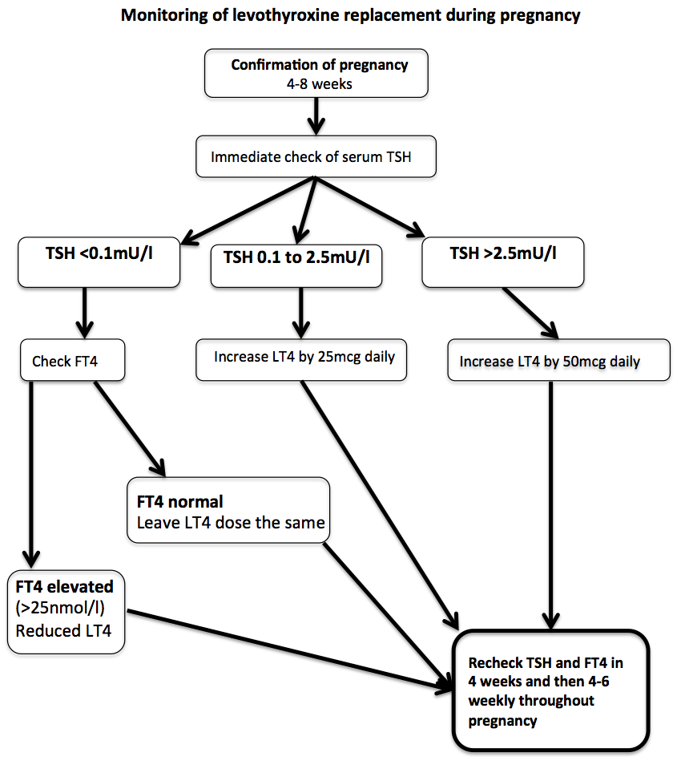

**Additional resources for Drs/ PAMs**

BTF/ACB UK Guidelines for use of thyroid function tests: July 2006 [www.british-thyroid-association.org/info-for-](http://www.british-thyroid-association.org/info-for-) patients/Docs/TFT_guideline_final_version_July_2006.pdf

RCP Radioiodine in the management of benign thyroid disease 2007 <http://www.rcplondon.ac.uk/pubs/contents/0621b67a-4880-4a1b-9942-> 57a666efee4a.pdf

BTA Guidelines for the management of thyroid cancer 2014 http://onlinelibrary.wiley.com/doi/10.1111/cen.12515/pdf

Endocrine Society. Guidelines for management of thyroid disease in pregnancy and postpartum 2007

[www.endo-society.org/guidelines/final/upload/Clinical-Guideline-Management-of-](http://www.endo-society.org/guidelines/final/upload/Clinical-Guideline-Management-of-) Thyroid-Dysfunction-during-Pregnancy-Postpartum.pdf

THYROID MANAGER: Online updated textbook of thyroidology

[www.thyroidmanager.org](http://www.thyroidmanager.org/)

Systematic review 2008: Management of hypothyroidism in adults. Vaidya & Pearce

[www.bmj.com/cgi/content/full/337/jul28_1/a801](http://www.bmj.com/cgi/content/full/337/jul28_1/a801)

European Thyroid Association Guideline 2013: Management of subclinical hypothyroidism. Pearce SH et al

www.ncbi.nlm.nih.gov/pmc/articles/PMC3923601

# Patient support organizations

British Thyroid Foundation

<http://www.btf-thyroid.org/>

Butterfly Thyroid Cancer Trust

[enquiries@butterfly.org](mailto:enquiries@butterfly.org)